**AQA**

**GCSE Science A**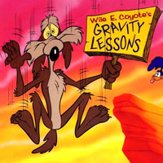

**Physics**

**Summary Notes**

**Energy**

**Energy Transfers**

Energy is transferred from one place to another in three ways:

1. Conduction

2. Convection

3. Radiation

**Conduction**

Metals are good at conducting heat (CONDUCTORS)

Plastic and wood are INSULATORS – don’t conduct heat.

If you heat one end of a copper rod, the heat transfers along the rod and

the other end will become hot.

e.g. heat bottom of a saucepan. The heat conducts through the copper bottom

to the water you are heating.



**Convection**

Can happen in liquids and gases.

Liquid/gas is heated, expands and rises

As it reaches the top it cools so falls back to bottom.

This is called a convection current.

e.g Occurs when heating rooms, heating water in a saucepan.



**Radiation**

Heat radiation is an electromagnetic wave – INFRA RED.

Anything above absolute zero will give off infra red radiation.

Some surfaces are better at giving out radiation than others

**Emitters** – giving out heat (infra red)

Black is a good emitter of heat.

e.g black radiator would emit more heat to a room than than a silver one.

Silver is a poor emitter of heat. Kettles are made of silver to that heat is not emitted to room. Survival blankets are made of shiny material so that the heat is not emitted from the person.

**Absorbers** – taking in heat (infra red)

Black is a good absorber of heat. Solar panels are black to absorb more heat from the sun.

Silver is a poor absorber of heat. Houses in hot countries are painted light colours so that they do not

absorb as much heat.

**Heat loss in a House**

Heat passes from warm inside

Through walls and windows by

CONDUCTION

Heat from house

rises upwards –

Convection Currents

and is lost through the roof



Heat transfer

Heat can be transfer by 3 methods

**Conduction:** Occurs in solids and felt by direct physical contact.

**Convection:** Occurs in liquids and gases. Hotter part rises, cooler part sinks.

**Radiation:** All objects do it. Can travel through empty space (vacuum) and travels in waves.

You can prevent heat loss from objects by using insulation. Air is a bad conductor of heat but makes a good insulator. For convection you must stop the heat from rising e.g. using a lid.

Trapped air helps to prevent heat loss by conduction and convection.

Radiation can be reduced by using light reflective surfaces. REMEMBER: Black is a good absorber and emitter of radiation but light and reflective surfaces and bad absorbers and emitters.

**Generating electricity: Fossil Fuels and Global Warming**

There are 3 fossil fuels – 1. COAL 2. OIL 3. GAS

Classed as NON-RENEWABLE – *one day will run out*

**

Fossil fuels are burnt to make ENERGY.

Carbon dioxide is produced when fossil fuels are burnt

in a power station.

Carbon dioxide is a GREENHOUSE GAS – it contributes

to GLOBAL WARMING.

What could happen if we heat up by CO2

2 degrees??

-Bigger desert – less land for farming

-More extreme weather

-Warmer winters

no snow = no winter sports

-Ice caps melt -

sea levels rise = flooding of some areas

-Disrupt The Gulf Stream –

UK could have extremely cold winters

SUNS HEAT ENERGY –

enters earth. Carbon dioxide stops

it escaping. Heat is trapped and so

earth warms up.



Burning fossils fuels also produces sulphur dioxide – which causes **ACID RAIN**.

Possible solution - Power station traps carbon dioxide before it is released and pump it via pipes to fill

old oil or gas wells. However, this would cost £30 per ton of gas made!

**Conservation of energy** = “the total energy you start with, equals the total energy you finish with”

The energy is TRANSFERRED from one type to another.

e.g Light Bulb

Electrical energy light (useful energy)

heat (not useful energy)



Efficiency – the amount of **USEFUL** energy you transfer

**Efficiency = useful energy out / total energy in x 100%**

If we say something is 30% efficient it means that 30% of the energy is useful, and 70% is wasted

e.g. out of 100Joules of energy – 30Joules is used and 70 Joules is wasted.

**Another equation involving Power**

Energy transferred = Power x Time

**Paying for your Electricity**

1. Work out how many units are used (kilowatt hours –kWh):

**Number of units (kWh) = Power (kW) x Time (hours)**

2. Work out cost

**Cost = Number of units (kWh) x cost per unit.**

*Example:*

*A 3kW heater is left on in your room from 8am til 4pm! How much will it cost if*

*the cost per unit is 10p?*

***Answer:***

*1. Work out units –*

*number of units = power x time*

*= 3kW x 8h*

*= 24kWh*

*2. Work out cost*

*cost = number of units x cost per unit*

*= 24 x 10p*

*= 240p (£2.40)*

**Generating Electricity**



1 - Burn fossil fuels

2 - Water becomes steam

3 - Steam turns turbine

4 - Turbine controls generator

5 - Electricity made

(NB. In nuclear power, the heat energy to make steam comes from uranium)

Not very efficient ( less than 40% ) – a lot of energy goes up the chimney as heat and is **WASTED.**

**The National Grid**

A network of power lines that connect all power stations together and supplies electricity to towns.

If one power station goes wrong, you can get your electricity from a different power station instead.



National Grid

**Transformers** – used to increase or decrease the voltage step up (increase voltage) and step down (decrease voltage).

When electricity LEAVES the power station, a **step up transformer** is used – *high voltage* means *low current.*

Low current means *less heat* produced and less heat produced means less *heat loss* (more efficient).

(Also, lower current means cables can be thinner, and lighter).

The **step down transformer** then takes this high voltage back to low voltage (and current is higher) to go into our house.

The power station HAS to supply the **correct** amount (the demand). The energy made from burning fossils fuels cannot be stored.

***To predict demand:***

- Special sensors provide information about the weather (colder weather – more electricity in heating.)

1500 floating buoys in Atlantic help provide long term weather predictions.

- Television companies make predictions about predicted audience for TV (e.g Wales v England rugby will mean lots of TV’s are on, which means more electricity is needed.

**Problem – fossils fuels will run out – where can we get our energy from?**

**NUCLEAR POWER Non renewable What is it?** Using substances like Uranium to make electricity.

**Advantage**

Doesn’t produce Carbon dioxide or other polluting gases

Huge amounts of energy produced

**Disadvantage**

Expensive to build (commission) and difficult to dismantle (decommission)

Difficult to get rid of radioactive waste

Accidents are catastrophic (Chernobyl)

**Non renewable** – one day metals like Uranium will run out.

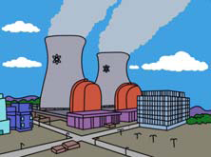

**Renewable Energy Resources**

Large wind turbines turn in the wind to produce electricity

**Advantage**

Low running cost

No air pollution

**Disadvantage**

Low power – need a LOT of them to make a decent output energy

Unsightly?

Noise pollution

40% efficient

Output not constant – no wind = no energy so need another source on standby

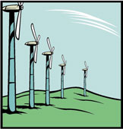

Wind Power

**What is it?**

Water flows through pipes from a high level reservoir.

As it flows, it turns at turbine, which is connected to

a generator which makes electricity.

**Advantage**

Low running cost

No air pollution

Reliable.

**Disadvantage**

Often require areas to be flooded which means a loss of habitats.

Only suitable for hilly areas.

Hydro electric power

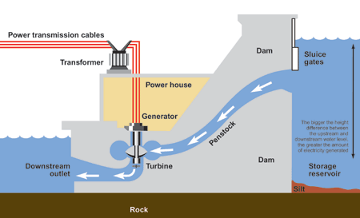

Wave Power

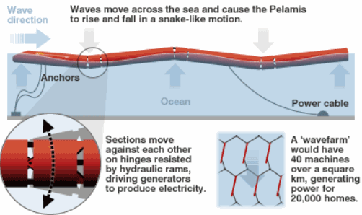

**What is it?**

A string of five cylinders is connected together with

Joins between each one.

Each cylinder moves with the waves and as it moves

oil is pumped through a hydraulic generator.

This makes electricity.

**Advantages**

Renewable – won’t run out.

No fuel costs

**Disadvantages**

An individual wave machine doesn’t produce much

electricity so you need many.

Wave farms unsightly?

**What is it?**

As the tide flows in and out, water passes over turbines

under water and this generates electricity.

More electricity made when tide goes OUT.

**Advantages**

No air pollution

Not a constant source of electrical energy.

Low running costs

**Disadvantages**

Have to be built across rivers – can cause problems for

Ships and for wildlife.

Tides change daily and monthly.

Tidal Power

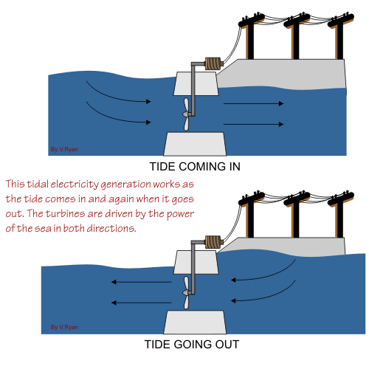

Biomass

**What is it?**

**Biofuels** are from fuels that are GROWN.

Plants grow and take in carbon dioxide and then when you

burn them they give out carbon dioxide. We say they are

**carbon neutral** (taking in and giving out of carbon cancel out!)

You can also burn animal waste, straw, trees. Make alcohol

from plants.

(use fast growing trees like Willow and poplar) – all BIOMASS.

**Advantages**

Biofuels are carbon neutral

**Disadvantages**

Energy isn’t concentrated so you need a lot of biofuels to make enough energy.

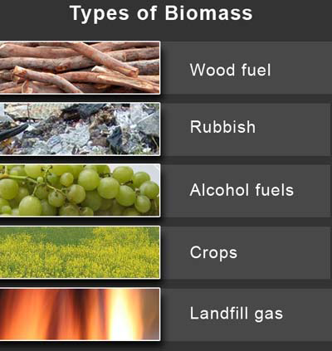

**WAVES**

Electromagnetic spectrum

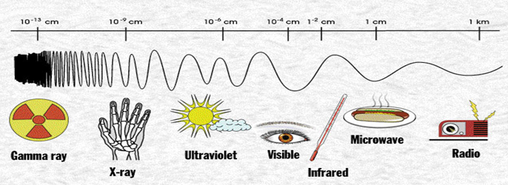

|  |  |  |
| --- | --- | --- |
| Part of the spectrum | Frequency (Hz) | Wavelength (m) |
| Gamma | Highest  Lowest | Shortest  Longest |
| X-ray |
| Ultraviolet |
| Visible |
| Infrared |
| Microwave |
| Radio |

The electromagnetic spectrum is energy that travels by waves. The only part of the spectrum that we can see is visible light. The electromagnetic spectrum has different properties, namely frequency and wavelength.

The frequency is the number of waves that occur every second. The frequency is measured in Hertz (Hz). The wavelength the distance between one point on the wave to the next corresponding point, measured in metres (m). The easiest way to think of it is the distance between one peak and the next peak, this is one complete wave.

**Wavelength**

All electromagnetic waves travel at the same speed in a vacuum (empty space). You can calculate the speed of a wave (measured in metres per second [m/s]) if you know the frequency and the wavelength.

Wave

Speed

Frequency

Wave

Length

$$Wave speed \left(m/s\right)= Frequency \left(Hz\right) ×Wavelength (m)$$

The visible part of the spectrum can be broken up also. The light that we see can be separated into the colours that compose white light. This can be done by passing light through a prism. A very common example of light getting separated is a rainbow, when light passes through raindrops.

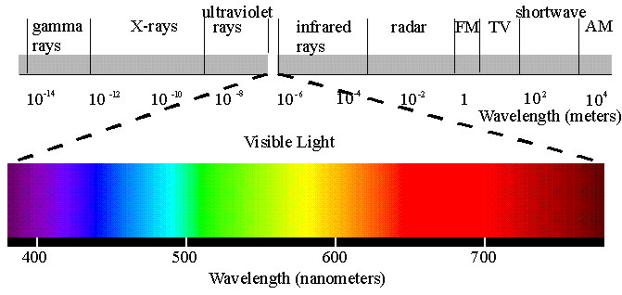

Violet Indigo Blue Green Yellow Orange Red

There are advantages and disadvantages to the different parts of electromagnetic spectrum

|  |  |  |
| --- | --- | --- |
| Part of the spectrum | Advantages | Disadvantages |
| Gamma | * To sterilise surgical instruments * To kill cancer cells | * High doses can kill cells * Low doses can cause cancer |
| X-ray | * To see bones * To kill cancer cells | * High doses can kill cells * Low doses can cause cancer |
| Ultraviolet | * In sun beds to give a tan * Identifying forgeries in money | * High doses can kill cells * Low doses can cause cancer (skin) |
| Visible | * For seeing and communication - optical fibre broadband | * Blindness |
| Infrared | * Communication e.g. remote control for TV * For cooking e.g. toaster | * Absorbed by skin and felt as heat * Excessive amounts cause burns |
| Microwave | * For communication in mobile phones and with satellites * Cooking food | * Absorbed by water in the cells, releasing heat, this can damage or kill the cells |
| Radio | * For communication without the use of satellites | * High levels can lead to tissue damage, particularly the ears * Large doses can cause cancer and leukaemia |

Communication

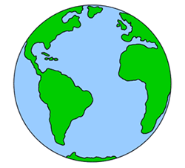The way radio waves can be used for communication with out satellites is due to charged particles in the Earth’s atmosphere. These particles reflect the radio waves back to Earth. So radio wave signals can be sent from one side of the Earth to the other. However, this doesn’t work for microwaves as they can pass through the atmosphere. So to communicate by microwaves you need to have a satellite in orbit to redirect the signal.

The way that light can be used for communication is in optical fibres. When the light travels through the optical fibre it gets reflects inside the fibre. This is called total internal reflection. This can also be used for infrared waves.

Light

Wave

Communication signals can either be sent as analogue or digital waves. Analogue signals are a continuous wave where as digital signals are a series of on-off pulses. Digital signals are less prone to interference than analogue signals.

Analogue signal

Digital signal

|  |  |
| --- | --- |
| Advantages and disadvantages of analogue and digital signals | |
| Digital signals | Analogue signals |
| Lose strength the further they travel | High quality for however far the pulses travel |
| Distort easily | Easily stored |
| Signal can be spoilt by interference | Signal and interference can be separated |
| Continuous signal | Discrete signal |

When radiation is absorbed the energy that it carries will cause the material to heat up. It can sometimes create an alternating current in the metal which will have the same frequency as the radiation itself.

Radiation wave

Aerial

**All About Waves**



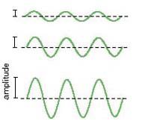

Change frequency. Keep amplitude the same Change amplitude. Keep frequency same

**Equations for speed of waves:**

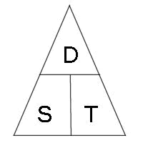

d = distance

F = frequency

$λ$ = wavelength

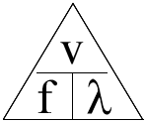

*speed = frequency x wavelength.*

*wavelength = speed / frequency*

*frequency = speed / wavelength*

**Electromagnetic Spectrum**

|  |  |  |  |  |  |  |
| --- | --- | --- | --- | --- | --- | --- |
| Rich | Men | In | Vegas | Use | X Rated | Girls |
| Radio | Micro | Infra red | Visible | Ultra violet | X Rays | Gamma |

*Increasing frequency*

All electromagnetic waves:

- Travel at same speed – 300 000 000 m/s

- Can be reflected/refracted

- Transfer energy from one place to another

**Radiowaves**

Long and medium radio waves are transmitted around the Earth by reflection from the upper part of the atmosphere

called the ionosphere. These are called SKY WAVES. Sometimes, signals from a transmitter have to be transmitted via satellites

**Microwaves**

1. Cooking: They heat water molecules and cause them to vibrate.

2. Communication: mobile phones and TV

If transmitters and receivers are in line with each other, microwaves can send signals direct from one

place to another (see a). If they are not in direct line, a microwave signal is sent up to a satellite in space

which then sends it back down to the correct location

**Infra – Red**

This is “HEAT”. Anything above -273 degrees celsius gives off infra red.

Uses – Infra-red cameras (used by police, fire service).

Remote controls

**Visible Light**

Red Richard

Orange Of

Yellow York

Green Gave

Blue Battle

Indigo In

Violet Vain



White light is made up of 7 colours. A prism will separate these colours as each colour refracts at a different angle.

**Reflection and Refraction**

When light hits a new surface, it can speed up or slow down and “bend”. This is known as **refraction**.

When it goes from a less dense substance (air) to a dense substance (glass) it bends TOWARDS the normal (slows down)

When it goes from a dense substance (glass) to a less dense substance (air) it bends AWAY from the normal (speeds up)



r

i

i = the angle of incidence

r = the angle of refraction.

**Red Shift**

Provides evidence for the ‘Big Bang’. Evidence that the galaxies are moving away

from us. ie the universe is expanding.

Longer wavelength is **RED** light

Shorter is BLUE light.

If galaxy is moving away from us, the wavelength “shifts” towards

the red end of the colour spectrum (wave ‘stretched out’ as frequency

is the same, but the wavelength increases)

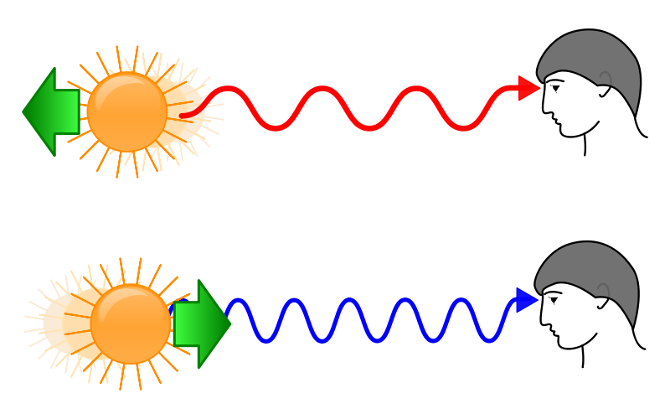

The more distant the galaxy, the greater the red shift. The more distant the galaxy, the faster it is travelling.

How does Red Shift provides evidence for the universe expanding?

Galaxies used to be closer together. They are now moving away.

Something must have caused them to move...the BIG BANG.

We believe this happened 12-15,000 million years ago.

**Space**

Everything thing in the universe began 14 billion years ago with what is called the **Big Bang**. The universe began as a small dense point and then began expanding.

C:\Documents and Settings\Administrator.DELL.000\Local Settings\Temporary Internet Files\Content.IE5\8A8RQ233\MC900232180[1].wmf There is evidence for this. When an object which emits light is stationary then the light it emits will be the same in all directions.

However, if an object is moving away from us the light waves get spread out which decreases the frequency. This makes the light appear red, we call this **red shift.** The bigger the red shift the further away the object is. If an object was moving towards us it would appear blue because frequency would be increased.

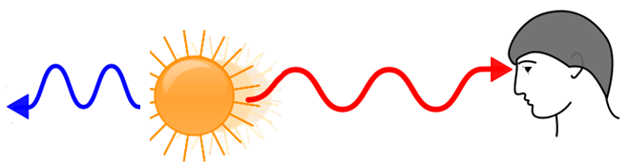

The way we can observe red shift more effectively is by looking at the spectrum of light given off by astronomical objects.

Sun’s spectrum

Another star’s spectrum

*Shifted towards the red* end

Violet Red

The spectrum from stars for example will have dark line appearing in them. These dark lines indicate what elements the star is composed of e.g. Hydrogen. So, since the Sun is so close to use we can consider it to be stationary. So we can compare the dark lines from other objects to the sun’s spectrum and if these dark lines are more towards the red end of the spectrum, then the object is moving away from us. If it is towards the violet end then it is moving towards us.

We observe the universe using telescopes but there are many different types of telescopes with detect different things. There are regular optical telescopes which detect visible light, there are radio telescopes which detect radio waves and there are also infrared and x-ray telescopes. Each type of telescope has its’ own strong and weak points.

|  |  |  |
| --- | --- | --- |
| **Telescope type** | **Advantage** | **Disadvantage** |
| Optical | Cheap. Observe visible light. | Observations can be affected by light pollution, air pollution and cloud cover. Need to be built on high mountains or in space |
| Radio | Radio waves aren’t affected as much by gas and dust. | They are more expensive. Large area needed. |
| Infrared | Can observe light that would otherwise be scattered. Are used to observe star formation regions and nebulae | Need to be built in space as Earth can absorb the heat. Expensive |
| X-Ray | Can detect the hottest regions of space. | Need to be built on mountains or in space as x-rays are absorbed by atmosphere. Expensive |

**The Big Bang**

Scientist think 23% of universe is made from DARK MATTER. They don’t know what this is though!

They think that 73% of the universe if made of “DARK ENERGY” which is pushing the universe apart.

10 billion years after big bang

galaxies and solar system formed.

Galaxies are moving away from

each other but gravity between them is slowing this down

1 billion years later galaxies begin to form

Universe exploded outwards from a tiny point